***Chemistry***

**7: Chemical Bonding and Molecular Structure**

**7.3: Lewis Symbols and Structures**

23. Write the Lewis symbols for each of the following ions:

(a) As3–

(b) I–

(c) Be2+

(d) O2–

(e) Ga3+

(f) Li+

(g) N3–

Solution

(a) eight electrons:

L:\Clients\Connexions\CONNEX130016_Chemistry\02_Working_Files\C07_Chemical Bonding and Molecular Geometry\99_Current_Art\JPEG\CNX_Chem_07_03_Question1a_img.jpg;

(b) eight electrons:

L:\Clients\Connexions\CONNEX130016_Chemistry\02_Working_Files\C07_Chemical Bonding and Molecular Geometry\99_Current_Art\JPEG\CNX_Chem_07_03_Question1b_img.jpg;

(c) no electrons

Be2+;

(d) eight electrons:

L:\Clients\Connexions\CONNEX130016_Chemistry\02_Working_Files\C07_Chemical Bonding and Molecular Geometry\99_Current_Art\JPEG\CNX_Chem_07_03_Question1d_img.jpg;

(e) no electrons

Ga3+;

(f) no electrons

Li+;

(g) eight electrons:

L:\Clients\Connexions\CONNEX130016_Chemistry\02_Working_Files\C07_Chemical Bonding and Molecular Geometry\99_Current_Art\JPEG\CNX_Chem_07_03_Question1g_img.jpg

25. Write the Lewis symbols of the ions in each of the following ionic compounds and the Lewis symbols of the atom from which they are formed:

(a) MgS

(b) Al2O3

(c) GaCl3

(d) K2O

(e) Li3N

(f) KF

Solution

(a)

L:\Clients\Connexions\CONNEX130016_Chemistry\02_Working_Files\C07_Chemical Bonding and Molecular Geometry\99_Current_Art\JPEG\CNX_Chem_07_03_Exercise3a_img.jpg;

(b)

L:\Clients\Connexions\CONNEX130016_Chemistry\02_Working_Files\C07_Chemical Bonding and Molecular Geometry\99_Current_Art\JPEG\CNX_Chem_07_03_Exercise3b_img.jpg;

(c)

L:\Clients\Connexions\CONNEX130016_Chemistry\02_Working_Files\C07_Chemical Bonding and Molecular Geometry\99_Current_Art\JPEG\CNX_Chem_07_03_Exercise3c_img.jpg;

(d)

L:\Clients\Connexions\CONNEX130016_Chemistry\02_Working_Files\C07_Chemical Bonding and Molecular Geometry\99_Current_Art\JPEG\CNX_Chem_07_03_Exercise3d_img.jpg;

(e)

L:\Clients\Connexions\CONNEX130016_Chemistry\02_Working_Files\C07_Chemical Bonding and Molecular Geometry\99_Current_Art\JPEG\CNX_Chem_07_03_Exercise3e_img.jpg;

(f)

L:\Clients\Connexions\CONNEX130016_Chemistry\02_Working_Files\C07_Chemical Bonding and Molecular Geometry\99_Current_Art\JPEG\CNX_Chem_07_03_Exercise3f_img.jpg

27. Write the Lewis structure for the diatomic molecule P2, an unstable form of phosphorus found in high-temperature phosphorus vapor.

Solution

L:\Clients\Connexions\CONNEX130016_Chemistry\02_Working_Files\C07_Chemical Bonding and Molecular Geometry\99_Current_Art\JPEG\CNX_Chem_07_03_Question5_img.jpg

29. Write Lewis structures for the following:

(a) O2

(b) H2CO

(c) AsF3

(d) ClNO

(e) SiCl4

(f) H3O+

(g) 

(h) 

(i) HCCH

(j) ClCN

(k) 

Solution

(a)

L:\Clients\Connexions\CONNEX130016_Chemistry\02_Working_Files\C07_Chemical Bonding and Molecular Geometry\99_Current_Art\JPEG\CNX_Chem_07_03_Question7a_img.jpg

In this case, the Lewis structure is inadequate to depict the fact that experimental studies have shown two unpaired electrons in each oxygen molecule*.*

(b)

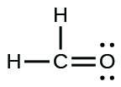;

(c)

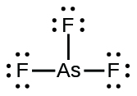;

(d)

L:\Clients\Connexions\CONNEX130016_Chemistry\02_Working_Files\C07_Chemical Bonding and Molecular Geometry\99_Current_Art\JPEG\CNX_Chem_07_03_Question7d_img.jpg;

(e)

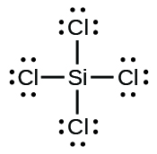;

(f)

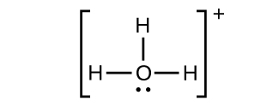;

(g)

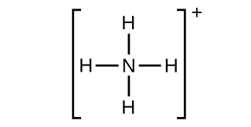;

(h)

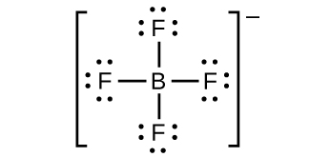;

(i)

L:\Clients\Connexions\CONNEX130016_Chemistry\02_Working_Files\C07_Chemical Bonding and Molecular Geometry\99_Current_Art\JPEG\CNX_Chem_07_03_Question7i_img.jpg;

(j)

L:\Clients\Connexions\CONNEX130016_Chemistry\02_Working_Files\C07_Chemical Bonding and Molecular Geometry\99_Current_Art\JPEG\CNX_Chem_07_03_Question7j_img.jpg;

(k)

L:\Clients\Connexions\CONNEX130016_Chemistry\02_Working_Files\C07_Chemical Bonding and Molecular Geometry\99_Current_Art\JPEG\CNX_Chem_07_03_Question7k_img.jpg

31. Write Lewis structures for the following:

(a) SeF6

(b) XeF4

(c) 

(d) Cl2BBCl2 (contains a B–B bond)

Solution

(a) SeF6:

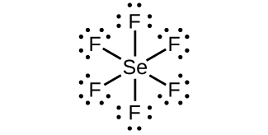;

(b) XeF4:

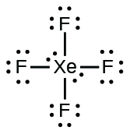;

(c) :

;

(d) Cl2BBCl2:

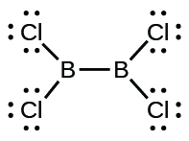

33. Correct the following statement: “The bonds in solid PbCl2 are ionic; the bond in a HCl molecule is covalent. Thus, all of the valence electrons in PbCl2 are located on the Cl– ions, and all of the valence electrons in a HCl molecule are shared between the H and Cl atoms.”

Solution

Two valence electrons per Pb atom are transferred to Cl atoms; the resulting Pb2+ ion has a 6*s*2 valence shell configuration. Two of the valence electrons in the HCl molecule are shared, and the other six are located on the Cl atom as lone pairs of electrons.

35. Methanol, H3COH, is used as the fuel in some race cars. Ethanol, C2H5OH, is used extensively as motor fuel in Brazil. Both methanol and ethanol produce CO2 and H2O when they burn. Write the chemical equations for these combustion reactions using Lewis structures instead of chemical formulas

Solution

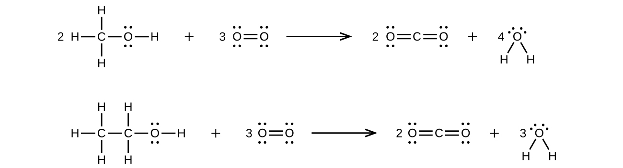

37. Carbon tetrachloride was formerly used in fire extinguishers for electrical fires. It is no longer used for this purpose because of the formation of the toxic gas phosgene, Cl2CO. Write the Lewis structures for carbon tetrachloride and phosgene.

Solution

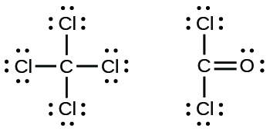

39. The arrangement of atoms in several biologically important molecules is given below. Complete the Lewis structures of these molecules by adding multiple bonds and lone pairs. Do not add any more atoms.

(a) the amino acid serine:

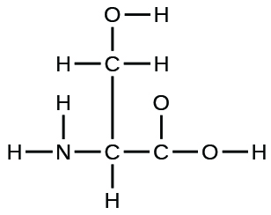

(b) urea:

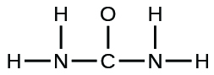

(c) pyruvic acid:

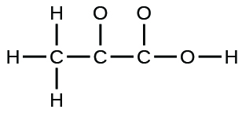

(d) uracil:

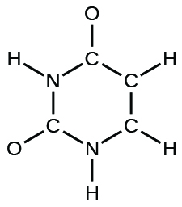

(e) carbonicacid:

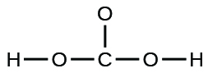

Solution

(a)

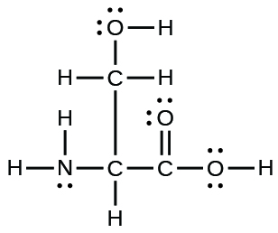;

(b)

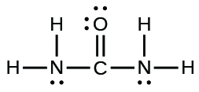;

(c)

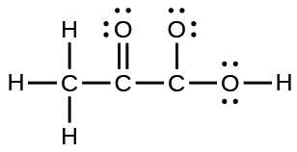;

(d)

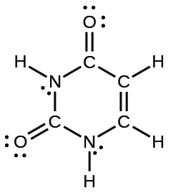;

(e)

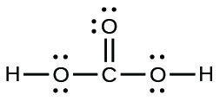

41. A compound with a molar mass of about 42 g/mol contains 85.7% carbon and 14.3% hydrogen by mass. Write the Lewis structure for a molecule of the compound.

Solution

A 100.0-g sample of this compound would contain 85.7 g C and 14.3 g H:

.

This is a ratio of 2 H to 1 C, or an empirical formula of CH2 with a formula mass of approximately 14. As , the formula is 3 × CH2 or C3H6. The Lewis structure is:

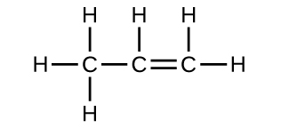

43. How are single, double, and triple bonds similar? How do they differ?

Solution

Each bond includes a sharing of electrons between atoms. Two electrons are shared in a single bond; four electrons are shared in a double bond; and six electrons are shared in a triple bond.

This resource file is copyright 2015, Rice University. All Rights Reserved.